|  |  |  |  |  |  |
| --- | --- | --- | --- | --- | --- |
| X | 0 | 1 | 2 | 3 | 4 |
| F(x) | 1 | 1.8 | 3.3 | 4.5 | 6.3 |

**Input:**

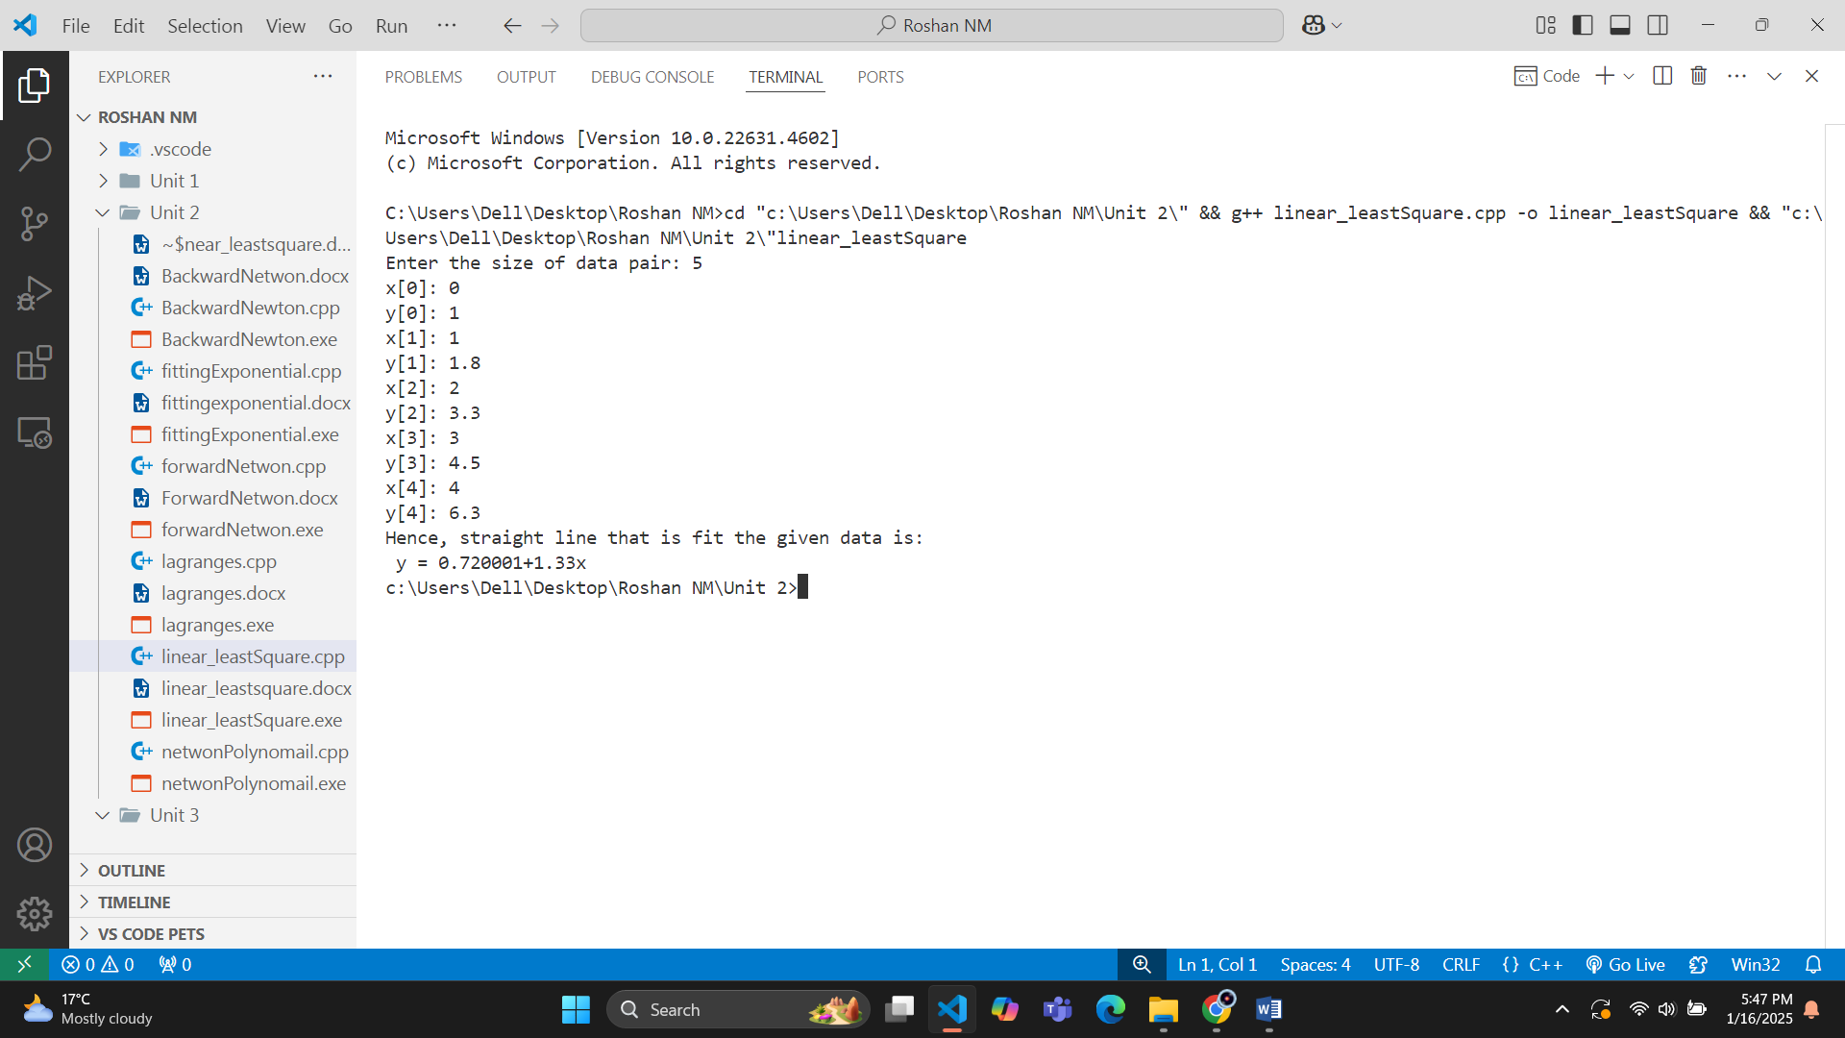**Output:**

|  |  |  |  |  |  |
| --- | --- | --- | --- | --- | --- |
| X | 4 | 7 | 11 | 13 | 17 |
| F(x) | 2 | 0 | 2 | 6 | 7 |

**Input:**

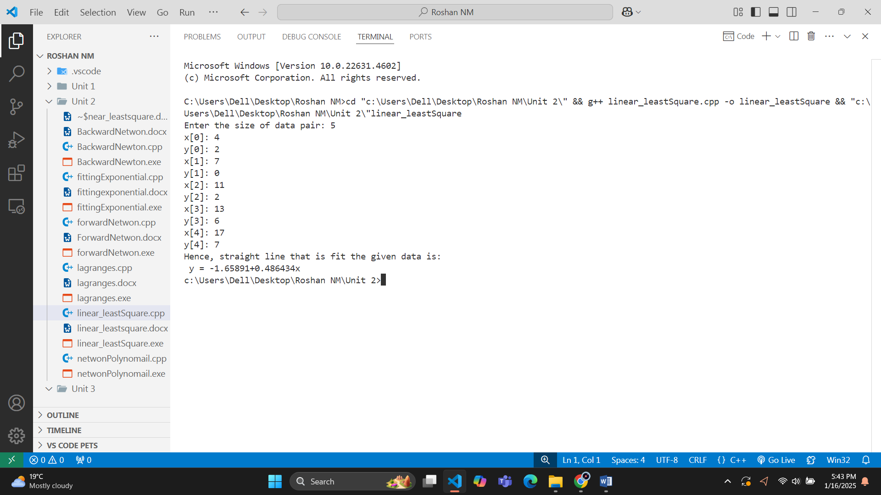**Output:**